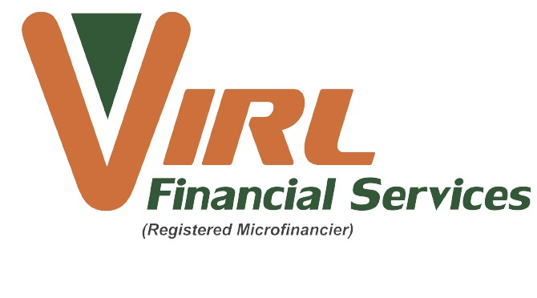

PROPOSAL FOR HOSPITAL CASH PLAN INSURANCE

PROPOSER’S NAME IN FULL …………………………………………………………………………… DOB …………………………………………

ID NUMBER ………………………………………………. GENDER …………………… POLICY NUMBER ………………..……………………….

E-MAIL ADDRESS………………………………………………………………………………………………………………………………………………………

RESIDENTIAL ADDRESS………………………………………………………………………………………………………………………………………………

………………………………………………………………………………………………………………………………………………………………………………

NAME OF NEXT OF KIN………………………………………………………………………………………

NEXT OF KIN PHONE NUMBER…………………………………………………………………………….

SELECT PRODUCT: RUBY USD PLATINUM USD GOLD USD

USD
 | platinum |  |  | Gold
 | Principal | Adult | Child | Principal | Adult | Child
Premium | US$ 3.20 | US$ 3.20 | US$ 2.20 | US$ 1.60 | US$ 1.60 | US$ 1.10
Daily Payout | US$ 200.00 | US$ 200.00 | US$ 120.00 | US$ 100.00 | US$ 100.00 | US$ 60.00
Monthly Payout | US$ 6,000.00 | US$ 6,000.00 | US$ 6,000.00 | US$ 3,000.00 | US$ 3,000.00 | US$ 1,800.00
Annual Payout | US$ 12,000.00 | US$ 12,000.00 | US$ 12,000.00 | US$ 6,000.00 | US$ 6,000.00 | US$ 3,600.00

INSURED PERSONS

Name in full ID/Birth entry no DOB Sex Product

1 Dependant ----------------------------------- --------------------------------------- ------------------ ------- ------------

2 Dependant ----------------------------------- --------------------------------------- ------------------ ------- ------------

3 Dependant ------------------------------------ --------------------------------------- ------------------ ------- ------------

4 Dependant ----------------------------------- --------------------------------------- ------------------ ------- ------------

5 Dependant ------------------------------------ --------------------------------------- ------------------ ------- ------------

6 Dependant ----------------------------------- --------------------------------------- ------------------ ------- ------------

7 Dependant ----------------------------------- --------------------------------------- ------------------ ------- ------------

DECLARATION

I HEREBY DECLARE THAT ALL THE INFORMATION PROVIDED IS IN ALL RESPECTS CORRECT AND THAT NO MATERIAL HAS BEEN SUPPRESSED OR WITHHELD AND THAT IF SUCH INFORMATION HAS BEEN PROVIDED ON MY BEHALF I AGREE THAT THIS DECLARATION AND THE ANSWERS GIVEN SHALL BE THE BASIS OF THE CONTRACT BETWEEN ME AND THE COMPANY AND THAT I ACCEPT THE USUAL CONDITIONS PRESCRIBED BY THE COMPANY AND ENDORSED ON THEIR POLICY.

I FURTHER AGREE THAT AS A RESULT OF MY ACCEPTANCE TO TAKE UP THE ABOVE COVER I AM GIVING PERMISSION TO MY EMPLOYER TO DEDUCT THE PREMIUM FROM MY SALARY (where applicable)

IT IS UNDERSTOOD THAT COVER DOES NOT COMMENCE UNTIL OFFICIALLY ACCEPTED BY THE COMPANY.

Dated this ---------------------Day of ---------------------------------------------2023

SIGNATURE OF PROPOSER___________________________

